Chesapeake Biological Laboratory’s Report of Monthly Cove Point Marsh Restoration Monitoring

Erin Reilly

March 14, 2019

## Activity Summary

#### February

* Salinity Surveys
* Download Weir Hobo Data
* Work on annual report

#### March (expected)

* Salinity Surveys
* Maintain Hobo sensors and download Hobo data for 4 stations
* Work on annual report

## Items of Note/Concern:

* When we intially deployed the Hobos in January, we deployed them in a similar way to how we have had the weir hobos out. A few Hobos were lost, likely due to greater exposure to wind,ice,depths, and animals. We attempted to recover them but were unsucessful. We went out again to fortify the Hobos. They are currently attached to the station using steel wire and protected by PVC. It is possible that the missing sensors may be recovered when the water warms up.
* An otter was seen in the area near the mid station

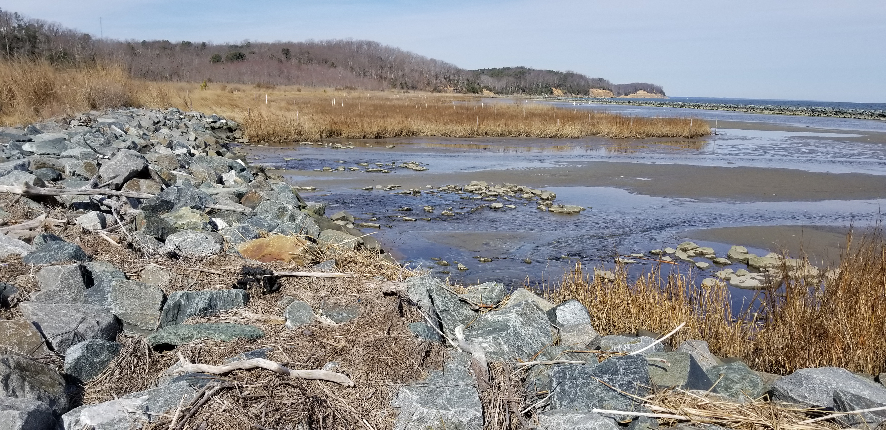

There was an extremely low tide February 26th.

## Plots

Below are the plots for the Hobos for the month of January.

### Water Level

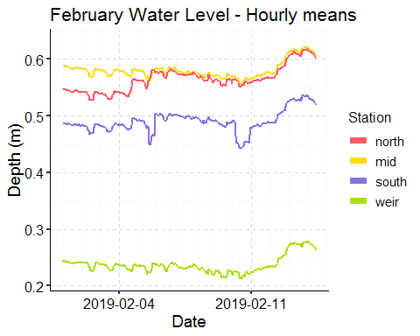

### Salinity

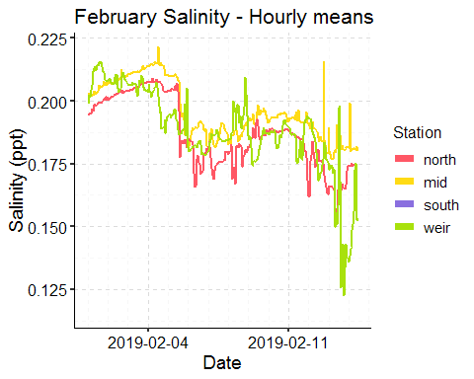

[Note that there are missing data points because of lost Hobos.]

### Dominion Distribution List

1. Paul Dickson, Dominion ([paul.e.dickson@dom.com](mailto:paul.e.dickson@dom.com))
2. Mike Gardner, Dominion ([Michael.e.gardner@dom.com](mailto:Michael.e.gardner@dom.com))
3. Jasmine L Morris ([Jasmine.L.Morris@dom.com](mailto:Jasmine.L.Morris@dom.com))
4. Dominion Biology Group Contact, Matt Overton ([matt.overton@dom.com](mailto:matt.overton@dom.com))